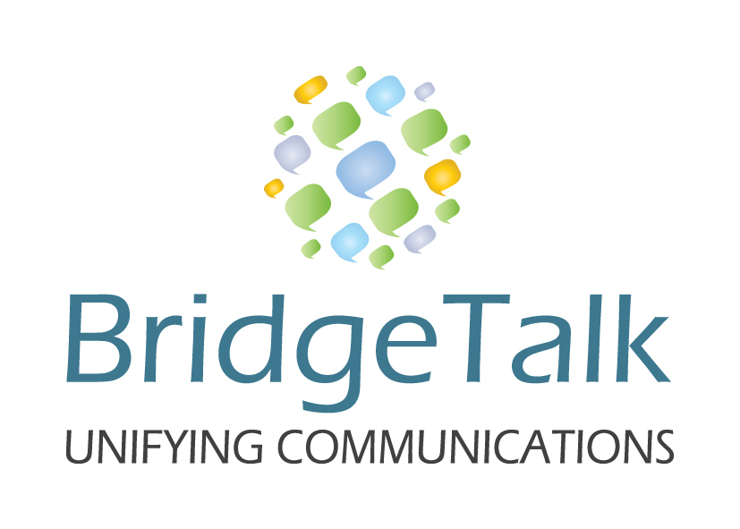
CUSTOMER ACCOUNT FORM
BRIDGE TALK
PLEASE COMPLETE ALL FIELDS IN ENGLISH AND EMAIL BACK

Company Name
Company Registration Number
Mailing Address (Street & No)
Mailing Address (City)
Mailing Address (Zip Code)
Main Switchboard Telephone Number
Contact Person
Contact Telephone Number (Office)
Contact Telephone Number (Cell)
Contact Email Address
GENERAL QUESTIONAIRE

Primary Calling Countries?
Expected number of conference calls each month?
How do you currently do your conference calls?
How did you hear about us?
CREDIT CARD DETAILS

Credit card type
Name on credit card
Credit card number
Expiration Date
3 digit code on back of card
I authorize Bridge-Talk Ltd to charge this credit card for the amount of our invoice each month.

*We agree that we are responsible for maintaining the confidentiality of our passcodes used in conjunction with the services provided by Bridge Talk limited and we are responsible for the cost of calls associated with each of Bridge Talk conference rooms and we will be charged as per the rates supplied at the time of opening our account. We agree to notify Bridge Talk Ltd of any unauthorized use of these passcodes as soon as we become aware of it.

*We agree to a 30 day payment term and we will notify Bridge Talk of any irregularities on our invoice within 14 days from that date that we receive the invoice. If our invoice is not paid within 30 days we are aware that our conference rooms may be suspended until payment is received by Bridge Talk Ltd.

Name: ________________________________

Signature: ______________________________

Company Stamp: _________________________

www.bridge-talk.co.il | info@bridge-talk.co.il | +972 72 213 3923

